Borehole No. Exploration Borehole No 3
Location Forifori
Latitude N06°50.175’
Longitude W00°19.236’
Date started 11/05/2001
Date completed 12/05/2001
Altitude about 340 ft (103.6m) – about 90ft (27.43m) above lake level

Summary Lithological Log
Depth(m)
From To
0 2 Laterite/clay
2 4.1 Very weathered silty subsoil
4.1 8.1 Very weathered sandy silt
8.1 12.2 Fairly weathered silty sand
12.2 20.3 Weathered to fairly hard mudstone/shale to medium grained sandstone
20.3 23.4 Fairly hard medium grained sandstone with siltstone
23.4 31.5 Fairly hard to hard siltstone with fine to medium sandstone
31.5 36.6 Hard to fairly hard siltstone
36.6 40.6 Fairly hard siltstone with fine to medium grained sandstone
40.6 46.7 Hard siltstone with fine to coarse grained sandstone
46.7 50.8 Hard siltstone and shale
50.8 55.9 Hard shale with some fine to coarse grained sand
55.9 62.0 Hard shale with fine grained sandstone
62.0 65.0 Hard shale
65.0 72.1 Hard shale to very fine grained sandstone
72.1 76.2 Hard siltstone to shale
76.2 78.2 Hard shale
78.2 81.3 Hard shale with very fine grained sandstone
81.3 84.3 Hard shale
84.3 88.4 Hard shale with medium grained sandstone
88.4 96.5 Hard shale
96.5 103.6 Hard shale with fine to medium grained sandstone

Comments on water production zones
First water struck – small amount (50 l/m) in weathered zone at 19m
Main water struck at 25m at base of fractured conglomerate zone with high flow rate of 1200 l/min. This is about 2 metres above the nominal lake level and therefore probably represents direct recharge from the lake located some 5km to the west.
The rate of inflow increases to 1500l/min at 40m at a thin fractured conglomerate zone.
Drilling stopped at 103m where flow rate >1500l/min obtained from within a fracture/weathered zone, this level coinciding with the former base level of the Volta River system before dam construction.

Detailed Lithological Log
Depth(m)
From To

Laterite/clay
0.0 1.0 7.5YR3/2 dark brown loamy, silty and clayey topsoil
1.0 2.0 10YR5/4 yellowish brown silty clayey topsoil

Very weathered silty subsoil
2.0 3.0 10YR5/2 greyish brown silty subsoil with odd fragment of very weathered
medium sandstone (Brown to light brown ochre very weathered silty medium
to coarse grained sandstone, some MnO₂ cement, soft with odd fairly well
rounded coarse sand and gravel fragments)
3.0 4.1 2.5Y5/4 light olive brown silty subsoil with fragments of very weathered
medium sandstone.

Very weathered sandy silt
4.1 5.1 10YR5/3 brown silty sandy subsoil with fragments of very weathered
medium sandstone. Some 10YR5/6 yellowish brown clay
5.1 6.1 10YR4/2 dark greyish brown sandy silty subsoil with very weathered to
fairly weathered light brown medium sandstone and brown mudstone
6.1 7.1 Gley 1 5/ grey silty sand with some highly weathered reddish grey medium
sandstone and more grey shale/mudstone (medium-hard) (Dark brown grey
very weathered medium sandstone and dark grey siltstone, soft and clayey)
7.1 8.1 Fairly weathered chocolate brown and grey mudstone with some very
weathered brown medium sandstone, some 10YR4/1 dark grey clay
Fairly weathered silty sand
8.1 9.1 7.5YR4/1 dark grey silty sand with fairly weathered to fairly hard chocolate
brown siltstone
9.1 10.2 7.5YR5/1 grey silty sand with hard grey mudstone to siltstone, some very
weathered brown medium sandstone
10.2 11.2 Hard light greenish grey siltstone with some fairly hard reddish grey medium
sandstone
11.2 12.2 Fairly weathered medium reddish grey sandstone with greenish grey fairly
hard mudstone to siltstone

Weathered to fairly hard mudstone/shale to medium grained sandstone
12.2 13.2 Grey siltstone to mudstone, fairly hard with some fairly weathered to very
competent grey and reddish grey sandstone
13.2 14.2 Fairly soft grey and red mudstone with fairly hard to hard reddish grey
sandstone
14.2 15.2 Fairly soft light grey with some red mudstone to shale interbedded with
weathered to fairly hard dark grey and greyish red medium sandstone
15.2 16.3 Fairly soft light grey with some red mudstone to shale interbedded with
weathered to fairly hard dark grey and greyish red medium sandstone
16.3 17.3 Weathered to fairly hard light grey mudstone with slightly weathered reddish
grey medium sandstone
17.3 18.3 Weathered light grey mudstone to shale (some shaley partings) with fairly
hard medium to fine reddish grey sandstone, interbedded
18.3 19.3 Weathered light grey mudstone with some red mudstone interbedded with
fairly hard red medium sandstone (FRACTURE – FIRST WATER
STRUCK – 50 L/MIN) (Red brown fine to medium sandstone interbedded
with grey siltstone to fine sandstone, fairly soft to fairly hard)
19.3 20.3 Competent dark red fine to medium sandstone interbedded with mainly grey
with some red weathered mudstone, with some black banded sandstone
(manganese oxide?)
Fairly hard medium grained sandstone with siltstone
20.3 21.3 Mainly grey and reddish grey competent medium sandstone with some light
grey mudstone to siltstone, a little white vein quartz (FRACTURE) (NB
water in adjacent well now dirty)
21.3 22.4 Dark red with some grey competent medium sandstone with very weathered
grey siltstone. Some white vein quartz
22.4 23.4 Reddish grey medium competent sandstone with some light grey soft to hard
siltstone, sometimes these are mixed. Some jasper and pyrite with calcite
(Light grey fairly soft fine sandstone with bands of hard quartzitic medium
sandstone)

Fairly hard to hard siltstone with fine to medium sandstone
23.4 24.4 Mainly fairly hard light grey siltstone with some competent fine to medium
grey sandstone. Quartz pebbles in the sandstone, very little pyrite and jasper.
Siltstone seems to grade into the fine sandstone
24.4 25.4 Fairly hard light and dark grey sandy siltstone, finer material has a slatey
cleavage, some competent grey fine sandstone (FRACTURE – 1200 L/MIN)
25.4 26.4 Mainly grey siltstone with a little competent grey fine to medium sandstone
26.4 27.4 Mainly grey siltstone with a little competent grey fine to medium sandstone,
with a little quartz
27.4 28.4 Fairly weathered fine grey siltstone with a little fairly hard grey fine
sandstone
28.4 29.5 Fine to medium hard grey siltstone with some fine to medium competent
sandstone, siltstone 'chunks' included in the sandstone in places
29.5 30.5 Mainly fine to medium hard grey siltstone with a little hard fine sandstone,
some pyrite and mica? Speckles
30.5 31.5 Hard grey siltstone with some fine, medium and coarse hard grey sandstone,
large 2-3mm quartz grains in coarse sandstone, some mica and pyrite
(Flow – 1200 l/min)
Hard to fairly hard siltstone
31.5 32.5 Fine to medium hard light and dark grey siltstone
32.5 33.5 Fine to medium hard light and dark grey siltstone some pyrite and hard grey
fine sandstone
33.5 34.5 Uniform fairly hard grey siltstone, some slatey cleavage
34.5 35.6 Uniform fairly hard grey siltstone, some slatey cleavage
35.6 36.6 Compact grey siltstone, slatey as well as more massive cleavage, grading
occasionally to hard fine grey sandstone
Fairly hard siltstone with fine to medium grained sandstone
36.6 37.6 Mainly compact grey siltstone, a little fine to medium dark grey sandstone
(black spackles) and a very little hard quartz rich sandstone
(Flow – 1200 l/min)
37.6 38.6 Mainly compact grey siltstone, a little fine to medium dark grey sandstone
(black spackles)
38.6 39.6 Mainly compact grey siltstone, some fine to medium hard reddish grey
sandstone, a little pyrite
39.6 40.6 Hard grey siltstone, a little medium reddish grey (some jasper) sandstone,
some calcite on cleavage planes
Hard siltstone with fine to coarse grained sandstone
40.6 41.7 Hard grey siltstone, with some fine reddish grey (small jasper grains) hard
sandstone (FRACTURE – 1500 L/MIN)
41.7 42.7 Fairly hard to hard grey siltstone some hard very fine grey sandstone
42.7 43.7 Hard grey siltstone with some fine, medium and coarse hard grey sandstone,
fragments of siltstone included (brecciated looking) in coarser sandstone (Fairly hard to fairly soft grey platey silty fine sandstone with thin medium
sandstone bands) (Flow – 1500 l/min)
43.7 44.7 Mainly hard grey siltstone with a little hard grey fine sandstone, some pyrite
44.7 45.7 Hard grey siltstone, some slatey partings grading in places to a fine hard
reddish grey sandstone
45.7 46.7 Hard to fairly hard grey siltstone with a little fine and medium to coarse
reddish grey sandstone
Hard siltstone and shale
46.7 47.8 Hard grey siltstone with shaley partings - is this a shale? (Grey platey
micaceous fine sandstone and blocky siltstone, fairly soft to fairly hard)
47.8 48.8 Hard grey siltstone with shaley partings, with a few coarser laminae
48.8 49.8 Hard grey shaley siltstone with slatey cleavage (Flow – 1500 l/min)
49.8 50.8 Hard grey shaley siltstone with slatey cleavage, with coarser and finer bands
Hard shale with some fine to coarse grained sand
50.8 51.8 Hard grey shale, some fine to medium reddish grey sandstone interbedded
51.8 52.8 Hard grey shale, some dark red staining
52.8 53.8 Hard grey shale, some weathered light grey siltstone - coarser than shale with
no cleavage
53.8 54.9 Hard grey shale, some black speckles (Mn?) especially on cleavage surfaces
54.9 55.9 Hard grey shale, some medium to coarse hard well cemented sandstone with
grains of mica, pyrite and jasper (Flow – 1500 l/min)
Hard shale with fine grained sandstone
55.9 56.9 Hard grey shale with some hard grey fine sandstone
56.9 57.9 Hard grey shale with some hard grey fine sandstone
57.9 58.9 Hard grey shale with some fine hard grey sandstone
58.9 59.9 Hard grey shale and hard very fine greyish red sandstone with black speckles
59.9 61.0 Hard grey shale, slatey fragments, some laminae of slightly coarser material
61.0 62.0 Hard grey shale, some light grey to reddish grey fine to medium sandstone
(Flow – 1500 l/min)
Hard shale
62.0 63.0 Hard grey shale with some slightly coarser material
63.0 64.0 Hard grey shale with some slightly coarser material
64.0 65.0 Hard grey shale
Hard shale to very fine grained sandstone
65.0 66.0 Hard grey shale and very fine hard grey sandstone, interbedded
66.0 67.1 Hard grey shale with some interbedded hard very fine grey sandstone (Grey
platey fairly micaceous silty fine sandstone, fairly soft to fairly hard)
67.1 68.1 Hard very fine grey sandstone with numerous mica specks, fairly weathered
to very hard grey shale (Flow – 1500 l/min)
68.1 69.1 Hard grey shale with some hard very fine to fine grey sandstone with some
reddish colouration
69.1 70.1 Hard grey shale, some very fine hard grey sandstone to siltstone
70.1 71.1 Hard grey shale, some very fine hard grey sandstone to siltstone
71.1 72.1 Hard grey shale with some coarser material and black staining on cleavage
faces
Hard siltstone to shale
72.1 73.2 Hard reddish grey fine siltstone with some hard grey shale
73.2 74.2 Slightly weathered to hard grey siltstone/shale (Flow – 1500 l/min)
74.2 75.2 Hard grey siltstone/shale with some hard grey medium sandstone with 1mm
quartz grains, black discolouration on shale partings
75.2 76.2 Hard grey siltstone/shale with some interbedded very fine hard grey
sandstone
Hard shale
76.2 77.2 Hard grey shale with black on partings
77.2 78.2 Hard grey shale, some black speckles
Hard shale with very fine grained sandstone
78.2 79.2 Hard grey shale with some reddish grey fine sandstone, some pyrite
79.2 80.3 Hard grey shale with some light grey very fine sandstone with black speckles
80.3 81.3 Hard grey shale with some very fine reddish grey sandstone
(Flow – 1500 l/min)
Hard shale
81.3 82.3 Uniform hard grey shale
82.3 83.3 Hard grey shale with grey fine sandstone some black speckles (Grey platey
fairly hard to fairly soft sandy siltstone)
83.3 84.3 Hard grey shale with grey fine sandstone some black speckles
Hard shale with medium grained sandstone
84.3 85.3 Hard grey shale with some reddish grey fine to medium hard sandstone with
black speckles
85.3 86.4 Hard grey shale with some light grey weathered medium sandstone
(FRACTURE)
86.4 87.4 Hard grey shale with some reddish grey hard medium sandstone
(Flow – 1500 l/min)
87.4 88.4 Hard grey shale and hard grey and reddish grey medium sandstone

Hard shale
88.4 89.4 Grey and greyish red fine to medium hard sandstone with some hard grey
shale
89.4 90.4 Hard grey shale with some reddish grey fine sandstone interbedded in parts
90.4 91.4 Interbedded hard grey shale and some coarser reddish grey material
91.4 92.5 Hard grey shale with some lighter grey slightly coarser siltstone
(Flow – 1500 l/min)
92.5 93.5 Hard grey shale with some reddish grey hard very fine sandstone with black
speckles
93.5 94.5 Uniform hard grey shale, some coarser and reddish grey laminae with black
speckles
94.5 95.5 Uniform hard grey shale, some coarser and reddish grey laminae with black
speckles
95.5 96.5 Uniform hard grey shale, fissile partings

Hard shale with fine to medium grained sandstone
96.5 97.5 Hard grey shale with lighter grey siltstone, some pyrite
97.5 98.6 Hard grey shale with some hard grey medium sandstone with black and red
speckles (Flow – 1500 l/min)
98.6 99.6 Hard grey shale with some hard grey to greyish red fine sandstone with red
and black speckles
99.6 100.6 Hard grey fine to medium sandstone with hard grey shale, some red and
black speckles with shale inclusions in the coarser sandstone
100.6 101.6 Hard grey shale with hard grey fine sandstone with black speckles
101.6 102.6 Hard grey fine sandstone with black speckles and pyrite, some hard grey
shale
102.6 103.6 Hard grey fine sandstone with black speckles and pyrite, some hard grey
shale (Grey platey fairly hard silty fine sandstone to sandy siltstone, some
white platey calcite)/(Blocky to platey grey silty fine sandstone, fairly hard
with some fairly soft weathered sandy siltstone) (Flow – >>1500 l/min)

Ghana |  | Test pumping |  |  | Point above GL |  |  | 0.7 | m
Borehole No. |  | TH003 |  |  | Pump depth |  |  | 50 | m
Village |  | Forifori |  |  | SWL |  |  | 13.65 | m
Date |  | 15/05/2001 |  |  | Start Time |  |  | 05:30
Drawdown test |  |  |  |  | Recovery test
t (mins) | wl (m) | s (m) | q (l/min) | Sp cap | t | t' | t/t' | wl (m) | s' (m)
0 | 13.65 |  |  |  | 480 | 0 |  | 15.83 | 2.18
1 | 14.16 | 0.51 | 417 | 817.65 | 481 | 1 | 481 | 15.2 | 1.55
2 | 14.22 | 0.57 | 417 | 731.58 | 482 | 2 | 241 | 15.18 | 1.53
3 | 14.27 | 0.62 | 417 | 672.58 | 483 | 3 | 161 | 15.15 | 1.5
4 | 14.28 | 0.63 | 417 | 661.9 | 484 | 4 | 121 | 15.14 | 1.49
5 | 14.3 | 0.65 | 417 | 641.54 | 485 | 5 | 97 | 15.13 | 1.48
6 | 14.31 | 0.66 | 417 | 631.82 | 486 | 6 | 81 | 15.12 | 1.47
7 | 14.32 | 0.67 | 417 | 622.39 | 487 | 7 | 69.57 | 15.11 | 1.46
8 | 14.34 | 0.69 | 417 | 604.35 | 488 | 8 | 61 | 15.1 | 1.45
9 | 14.35 | 0.7 | 417 | 595.71 | 489 | 9 | 54.33 | 15.09 | 1.44
10 | 14.36 | 0.71 | 417 | 587.32 | 490 | 10 | 49 | 15.08 | 1.43
15 | 14.4 | 0.75 | 417 | 556 | 495 | 15 | 33 | 15.06 | 1.41
20 | 14.44 | 0.79 | 417 | 527.85 | 500 | 20 | 25 | 15.04 | 1.39
25 | 14.47 | 0.82 | 417 | 508.54 | 505 | 25 | 20.2 | 15.02 | 1.37
30 | 14.5 | 0.85 | 417 | 490.59 | 510 | 30 | 17 | 15 | 1.35
35 | 14.53 | 0.88 | 417 | 473.86 | 515 | 35 | 14.71 | 14.99 | 1.34
40 | 14.55 | 0.9 | 417 | 463.33 | 520 | 40 | 13 | 14.98 | 1.33
45 | 14.57 | 0.92 | 417 | 453.26 | 525 | 45 | 11.67 | 14.97 | 1.32
50 | 14.59 | 0.94 | 417 | 443.62 | 530 | 50 | 10.6 | 14.96 | 1.31
55 | 14.61 | 0.96 | 417 | 434.38 | 535 | 55 | 9.727 | 14.95 | 1.3
60 | 14.63 | 0.98 | 417 | 425.51 | 540 | 60 | 9 | 14.94 | 1.29
75 | 14.7 | 1.05 | 417 | 397.14 | 555 | 75 | 7.4 | 14.91 | 1.26
90 | 14.75 | 1.1 | 417 | 379.09 | 570 | 90 | 6.333 | 14.88 | 1.23
105 | 14.81 | 1.16 | 417 | 359.48 | 585 | 105 | 5.571 | 14.85 | 1.2
120 | 14.85 | 1.2 | 417 | 347.5 | 600 | 120 | 5 | 14.83 | 1.18
135 | 14.9 | 1.25 | 417 | 333.6 | 615 | 135 | 4.556 | 14.81 | 1.16
150 | 14.95 | 1.3 | 417 | 320.77 | 630 | 150 | 4.2 | 14.79 | 1.14
165 | 15 | 1.35 | 417 | 308.89 | 645 | 165 | 3.909 | 14.77 | 1.12
180 | 15.05 | 1.4 | 417 | 297.86 | 660 | 180 | 3.667 | 14.75 | 1.1
195 | 15.1 | 1.45 | 417 | 287.59 | 690 | 210 | 3.286 | 14.72 | 1.07
210 | 15.13 | 1.48 | 417 | 281.76 | 720 | 240 | 3 | 14.69 | 1.04
225 | 15.18 | 1.53 | 417 | 272.55
240 | 15.22 | 1.57 | 417 | 265.61
255 | 15.27 | 1.62 | 417 | 257.41
270 | 15.32 | 1.67 | 417 | 249.7
285 | 15.36 | 1.71 | 417 | 243.86
300 | 15.4 | 1.75 | 417 | 238.29
315 | 15.44 | 1.79 | 417 | 232.96
330 | 15.48 | 1.83 | 417 | 227.87
345 | 15.53 | 1.88 | 417 | 221.81
360 | 15.57 | 1.92 | 417 | 217.19
390 | 15.64 | 1.99 | 417 | 209.55
420 | 15.71 | 2.06 | 417 | 202.43
450 | 15.77 | 2.12 | 417 | 196.7
480 | 15.83 | 2.18 | 417 | 191.28

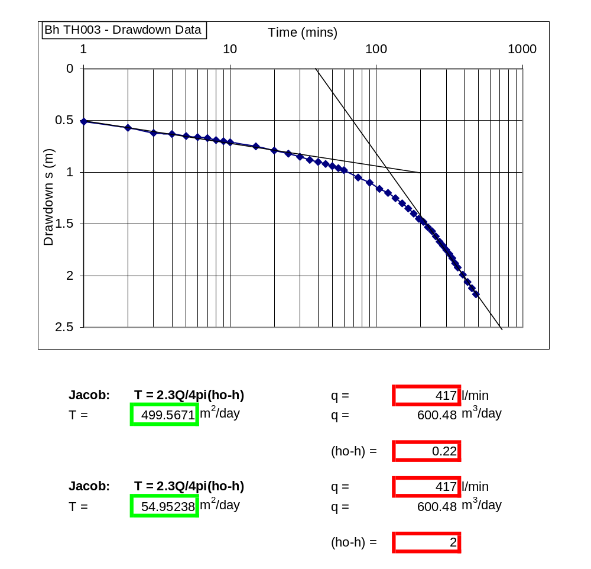

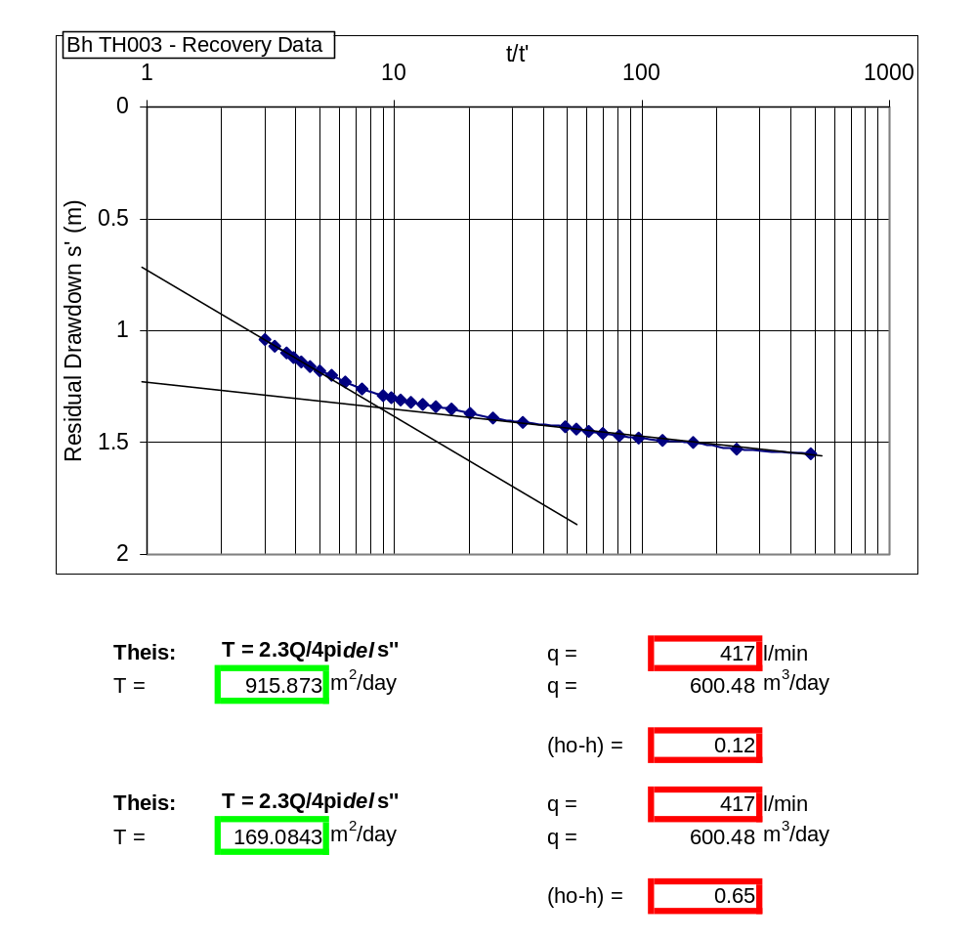

Ghana |  | Test pumping
Borehole No. |  | TH003 | Obs Bh | r | 19.4 | m
Village |  | Forifori |  | Pump depth |  | 50 | m
Date |  | ######## |  | SWL |  | 13.65 | m
Point above GL |  | 0.7 | m | Start Time |  | 05:30
Drawdown test |  |  |  | Recovery test
t (mins) | wl (m) | s (m) | q (l/min) | t | t' | t/t' | wl (m) | s' (m)
0 | 13.67 |  | 417 | 480.00 | 0.00 |  | 15.90 | 2.23
1 | 14.12 | 0.45 | 417 | 481.00 | 1.00 | 481.00 | 14.60 | 0.93
2 | 14.19 | 0.52 | 417 | 482.00 | 2.00 | 241.00 | 14.50 | 0.83
3 | 14.23 | 0.56 | 417 | 483.00 | 3.00 | 161.00 | 14.46 | 0.79
4 | 14.26 | 0.59 | 417 | 484.00 | 4.00 | 121.00 | 14.45 | 0.78
5 | 14.28 | 0.61 | 417 | 485.00 | 5.00 | 97.00 | 14.44 | 0.77
6 | 14.29 | 0.62 | 417 | 486.00 | 6.00 | 81.00 | 14.43 | 0.76
7 | 14.31 | 0.64 | 417 | 487.00 | 7.00 | 69.57 | 14.42 | 0.75
8 | 14.32 | 0.65 | 417 | 488.00 | 8.00 | 61.00 | 14.41 | 0.74
9 | 14.33 | 0.66 | 417 | 489.00 | 9.00 | 54.33 | 14.40 | 0.73
10 | 14.34 | 0.67 | 417 | 490.00 | 10.00 | 49.00 | 14.39 | 0.72
15 | 14.38 | 0.71 | 417 | 495.00 | 15.00 | 33.00 | 14.35 | 0.68
20 | 14.41 | 0.74 | 417 | 500.00 | 20.00 | 25.00 | 14.33 | 0.66
25 | 14.44 | 0.77 | 417 | 505.00 | 25.00 | 20.20 | 14.30 | 0.63
30 | 14.46 | 0.79 | 417 | 510.00 | 30.00 | 17.00 | 14.28 | 0.61
35 | 14.49 | 0.82 | 417 | 515.00 | 35.00 | 14.71 | 14.26 | 0.59
40 | 14.51 | 0.84 | 417 | 520.00 | 40.00 | 13.00 | 14.24 | 0.57
45 | 14.54 | 0.87 | 417 | 525.00 | 45.00 | 11.67 | 14.22 | 0.55
50 | 14.56 | 0.89 | 417 | 530.00 | 50.00 | 10.60 | 14.20 | 0.53
55 | 14.58 | 0.91 | 417 | 535.00 | 55.00 | 9.73 | 14.19 | 0.52
60 | 14.61 | 0.94 | 417 | 540.00 | 60.00 | 9.00 | 14.18 | 0.51
75 | 14.72 | 1.05 | 417 | 555.00 | 75.00 | 7.40 | 14.15 | 0.48
90 | 14.8 | 1.13 | 417 | 570.00 | 90.00 | 6.33 | 14.12 | 0.45
105 | 14.88 | 1.21 | 417 | 585.00 | 105.00 | 5.57 | 14.09 | 0.42
120 | 14.93 | 1.26 | 417 | 600.00 | 120.00 | 5.00 | 14.07 | 0.40
135 | 14.98 | 1.31 | 417 | 615.00 | 135.00 | 4.56 | 14.05 | 0.38
150 | 15.02 | 1.35 | 417 | 630.00 | 150.00 | 4.20 | 14.02 | 0.35
165 | 15.07 | 1.4 | 417 | 645.00 | 165.00 | 3.91 | 14.00 | 0.33
180 | 15.12 | 1.45 | 417 | 660.00 | 180.00 | 3.67 | 13.98 | 0.31
195 | 15.16 | 1.49 | 417 | 690.00 | 210.00 | 3.29 | 13.95 | 0.28
210 | 15.2 | 1.53 | 417 | 720.00 | 240.00 | 3.00 | 13.92 | 0.25
225 | 15.25 | 1.58 | 417
240 | 15.3 | 1.63 | 417
255 | 15.35 | 1.68 | 417
270 | 15.39 | 1.72 | 417
285 | 15.43 | 1.76 | 417
300 | 15.48 | 1.81 | 417
315 | 15.52 | 1.85 | 417
330 | 15.57 | 1.9 | 417
345 | 15.61 | 1.94 | 417
360 | 15.66 | 1.99 | 417
390 | 15.73 | 2.06 | 417
420 | 15.79 | 2.12 | 417
450 | 15.84 | 2.17 | 417
480 | 15.9 | 2.23 | 417

